**E-commerce Sales Analysis Report (Jan - Feb 2025)**

**1. Executive Summary**

This report provides a data-driven analysis of our e-commerce sales performance from January 1st to February 28th, 2025, using data from our customers, products, and orders tables. The analysis answers key business questions related to sales, customers, products, and geographical performance, providing a comprehensive overview of the business health.

**Key Findings:**

* **Total Sales:** The company generated **$3,260.00** in total sales from **12** unique orders.
* **Best-Selling Products:** The Laptop and Mouse were our top-selling products by quantity and revenue.
* **Customer Insights:** We have a total of **10** unique customers. Two of them are returning customers, while the remaining eight are new customers who have placed a single order.
* **Geographic Performance:** New York is our top-performing city by sales, followed by Tokyo and Sydney.

**2. Detailed Findings**

**Question 1: What are the total sales, total orders, and average order value?**

**Query:**

select sum(total_price)as total_sales,

count(*)as total_orders,

sum(total_price)/count(*) as avg_order_value from orders

**Output**



**Question 2: What are the monthly and daily sales trends?**

**Query:**

select month(order_date),day(order_date),sum(total_price) from orders group by month(order_date),day(order_date)

**Output:**

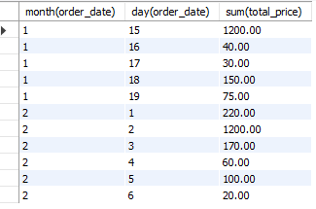

**Insight:** Sales are not consistent. There are high-volume days, particularly on January 15 and February 2, suggesting product-specific sales spikes.

**Question 3: What is our total revenue for the current year?**

**Query:**

select year(order_date),sum(total_price)as total_revenue from orders

where year(order_date)=year(curdate())

group by year(order_date)

**Output:**



**Insight:** This figure represents our year-to-date total sales, and it can be used as a key performance indicator (KPI) to track our revenue growth.

**Question 4: Who are our top 10 customers by total spending?**

**Query:**

select o.customer_id,sum(total_price) as totalsales from customers c join orders o

on c.customer_id=o.customer_id group by o.customer_id order by totalsales desc limit 10

**Output:**

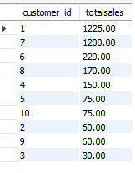

**Insight:**customer_id with 1,7 are the top2 customers with totalsales greater than 1000

**Question 5: How many unique customers have placed an order?**

**Query:**

select count(distinct customer_id) as unique_cus from orders

**Output:**



**Question6:How many different customers have placed more than one order?**

**Query:**

select customer_id,count(customer_id) as unique_cus from orders group by customer_id having count( customer_id)>1

**Output:**



**Question7:divide the customers into two categories(old and new) and count how many are in each category?**

**Query:**

select customer_id,count(*) as cust_count ,

case

when count(customer_id)>1 then 'old'

else 'new'

end as ctype

from orders group by customer_id

**Output:**

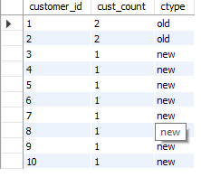

**Insight:** The majority of our customer base is new, indicating a strong acquisition rate.

**Question 8: What are the top 5 best-selling products by quantity and revenue?**

**Query:**

select product_name,sum(quantity) as total_quantity_sold,sum(total_price) as total_revenue

from products p join orders o on p.product_id=o.product_id group by product_name

order by total_quantity_sold desc ,total_revenue desc limit 5

**Output:**

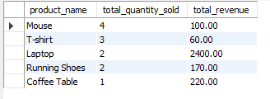

**Insight:** The Mouse&t-shirt are top2 according to quantity and Laptop and coffee table are top2 according to revenue

**Question 9: What is the average price of products in each category?**

**Query:**

select category,round(avg(price),2) as avg_price from products group by category

**Output:**

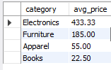

**Question 10: What are the top 5 cities by total sales?**

**Query:**

select city,sum(total_price) as total_sale from customers c join orders o

on c.customer_id=o.customer_id group by city

order by total_sale desc limit 5

**Output:**

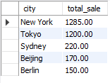

**Insight:** New York and Tokya has highest sales, reinforcing its importance as a key market for our business.

**Question 11:Which city has highest number of customers?**

**Query:**

select city,count(*) as total_customers from customers group by city

order by total_customers desc limit 1

**Output:**



**Insight:** New York has the most customers, reinforcing its importance as a key market for our business.

## 3. Recommendations and Next Steps

Based on the analysis, we recommend the following actions:

* **Focus on Customer Retention:** Since most of our customers are new, we should provide quality in product and provide discount encourage repeat purchases.
* **Optimize Product Marketing:** Run targeted ads for the 'Laptop' and 'Mouse' in our top-performing cities (New York and Tokyo).
* **Geographic Expansion:** Consider further expansion and marketing in New York and other top-performing cities to capitalize on existing demand